**USA Incubator Settings**

LW Scientifics digital incubators are controlled by a PID. A PID is a complex temperature controller. It uses several different algorithms to determine the best curve for the temperature set point. With this in mind, there are many important settings in the PID that must not be altered from the factory settings. This instruction covers our 10L, 20L, and 30L USA Incubators.

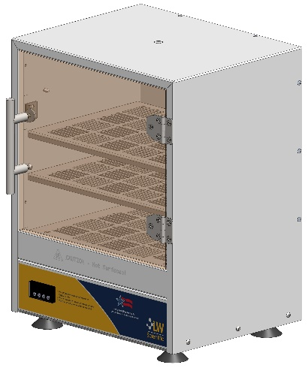

Use this instruction to verify or restore the factory setting of your PID. Please note this covers three different models. You will need to know which model you have, a 10L, 20L, or 30L, then choose the correct column for your proper settings from the table below.

There are several areas for setting PID parameters, and they are accessed in different ways. Some settings are more easily accessible and are there for you to choose your preference, such as temperature units, either °F or °C. These settings are covered in the operation manual as well.

To access the general settings, press the set key, then use the arrows and set the display to 0089 and press the set kay again. Then by using the arrows you can choose which parameter to change or verify. Once you find the parameter, press the set key, and use the arrows to change the parameter. Once the desired value for the parameter is correct, press the set key again. When parameter changes or verification are complete, use the arrows until you reach the parameter END, press set to return to normal operation.

|  |  |  |  |  |  |  |  |
| --- | --- | --- | --- | --- | --- | --- | --- |
| ***Table 1 (PID parameters, Incubator)*** | | | | | | | |
| ***for access, enter code 0089*** | | |  |  |  |  |  |
| **Code** | | **Description** | **Setting Range** | **Initial** | **10L** | **20L** | **30L** |
| **inty** | Inty | Input Sensor Type | -99.9~600.0°C; -99.9~999.9°F | K | P10.0 | P10.0 | P10.0 |
| **End** | End | Exit |  |  |  |  |  |
| **CorF** | CorF | Display Unit | 0: °C 1:°F | 1 | 1 | 1 | 1 |
| **rd** | rd | Control Function | 0: heating 1: Cooling | 0 | 0 | 0 | 0 |
| **PSb** | PSb | Input Offset | -100~100(deg) | 0 | 0 | 0 | 0 |
| **Hy** | Hy | Hysteresis Band | 0~9999 | 3 | 3 | 3 | 3 |
| **outy** | outy | Control Output Mode | 0, 1, 2, 3, 4, 5 | 2 | 2 | 2 | 2 |

Almost any issue can be corrected by verifying the general settings. If there is still an issue, you may access the following.

Along with the general settings there are parameters that help us control the PID. These setting tell the PID things that affect the ramp and curves. These are not covered in a standard operation manual and should only be verified or returned to the factory settings in the table, please do not deviate from the factory settings.

To access these settings, press the set key, then use the arrows and set the display to 0036 and press the set kay again. Then by using the arrows you can choose which parameter to change or verify. Once you find the parameter, press the set key, and use the arrows to change the parameter. Once the desired value for the parameter is correct, press the set key again. When parameter changes or verification are complete, use the arrows until you reach the parameter END, press set to return to normal operation.

|  |  |  |  |  |  |  |  |
| --- | --- | --- | --- | --- | --- | --- | --- |
| ***Table 2 (PID parameters, Incubator)*** | | | | | | | |
| ***for access, enter code 0036*** | | |  |  |  |  |  |
| **Symbol** | | **Description** | **Setting Range** | **Initial** | **10L** | **20L** | **30L** |
| **P** | P | Proportional Constant | 0.1~99.9(%) | 5 | 3.7 | 3 | 2.6 |
| **End** | End | Exit |  |  |  |  |  |
| **FILt** | FILt | Digital Filter Strength | 0~3 | 0 | 0 | 0 | 0 |
| **ot** | ot | Cycle Rate | 2~199(Sec) | 2 | 2 | 2 | 2 |
| **SouF** | SouF | Damp Constant | 0.1~1.0 | 0.2 | 0.2 | 0.2 | 0.2 |
| **d** | d | Derivative Time | 0~399(Sec) | 20 | 300 | 300 | 275 |
| **I** | I | Integral Time | 2~1999(Sec) | 100 | 1200 | 1200 | 1100 |

Please note that incubators react very slowly so they can maintain high tolerance constant temperatures. Therefore, after any parameter change, allow one hour or more for the incubator change to take effect and stabilize.

For any further questions, please contact the LW Scientific service department at (800) 726-7345.